**Name:** Bashar Tukur Shehu **Fellow ID:** FE/23/70792034  **Cohort:** Cohort 3

**A Report on Setting up Networking Simulation Tool**

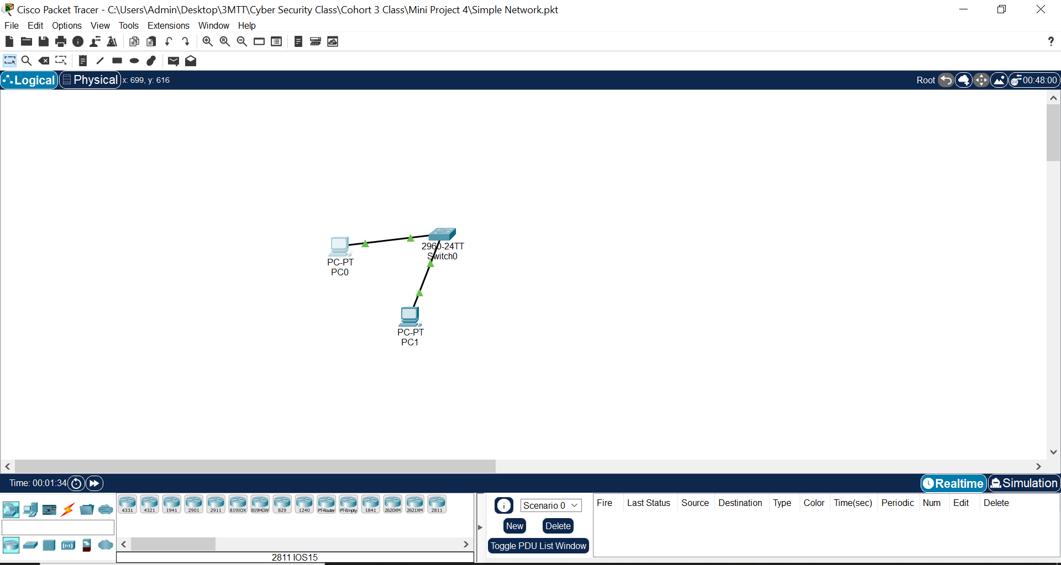

**Figure 1:** Setting up a simple network

Steps:

1. Launch **Cisco Packet Tracer** and sign in with your account.
2. Locate the **End Devices** section in the left panel.
3. Drag **two PCs** (PC-0 and PC-1) into the workspace.
4. Navigate to the **Switches** section and drag a **switch** into the workspace.
5. Click the **Connections** icon (represented by a lightning bolt).
6. Choose the **copper straight-through cable**.
7. Click **PC-0**, select **FastEthernet0** as the interface.
8. Click the **Switch**, select any available **FastEthernet port** (e.g., **FastEthernet0/1**).
9. Repeat 6 to connect **PC-1** to the switch (e.g., **FastEthernet0/2**).
10. Click **PC-0** > Select **Desktop** > Open **IP Configuration**.

Assign the following:

* + **IP Address**: 192.168.1.1
  + **Subnet Mask**: 255.255.255.0

Close the window and repeat the process for **PC-1**:

* + **IP Address**: 192.168.1.2
  + **Subnet Mask**: 255.255.255.0

1. Click **PC-0** > **Desktop** > Open **Command Prompt**.

Type the command:

**ping 192.168.1.2**

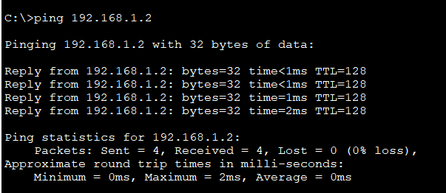

**Figure 2**: Result from the command ‘ping 192.168.1.2’